**🧾 Task 7 – Sales Summary using SQLite and Python**

**📌 Objective**

The goal of this task was to:

* Connect Python to a SQLite database (sales_data.db)
* Run SQL queries to get product-wise **total quantity** and **total revenue**
* Load the data into a pandas DataFrame
* Display the results in tabular format using print()
* Visualize the revenue per product using a simple bar chart via matplotlib

**🛠️ Tools & Libraries Used**

* **Python** – Programming language
* **SQLite** – Lightweight SQL database (no setup needed!)
* **sqlite3** – Python’s built-in library to connect with SQLite
* **pandas** – For data loading and manipulation
* **matplotlib** – For creating a basic bar chart
* **Jupyter Notebook** – For running the code interactively

**🧠 What I Did – Step-by-Step**

**1️⃣ Created SQLite Database**

A database file named sales_data.db was used, containing a single table: sales.

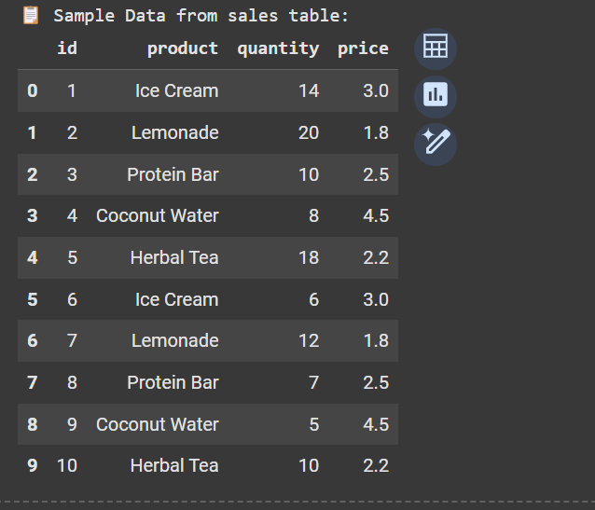

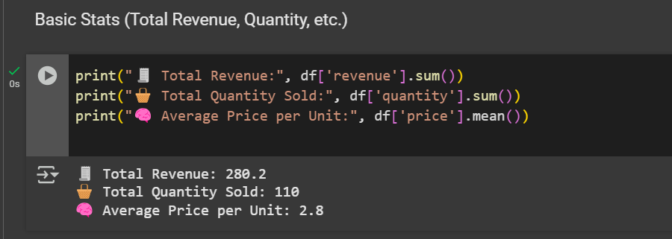

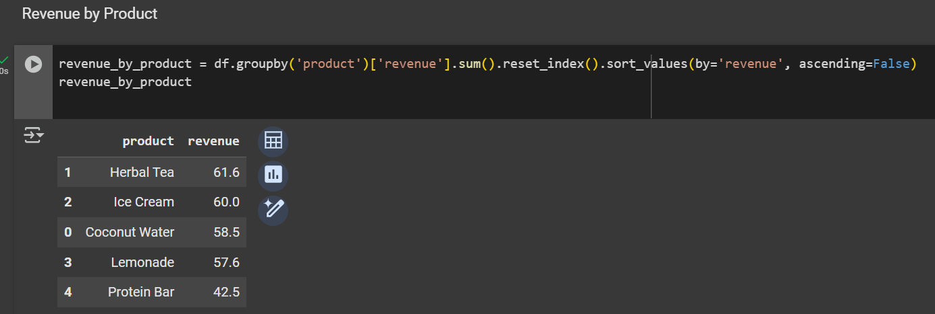

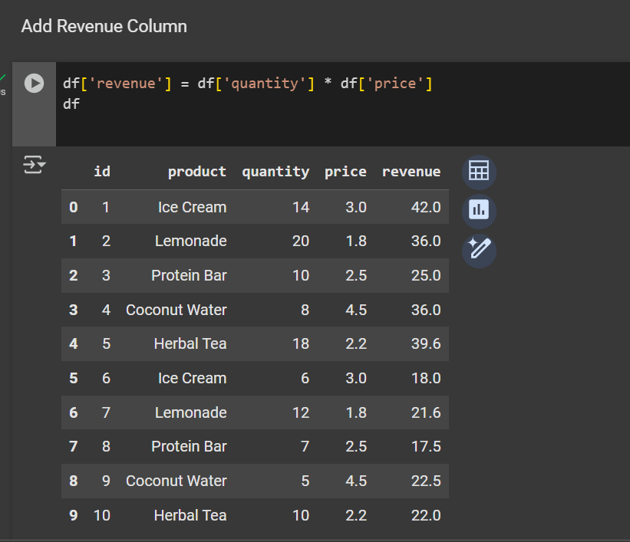

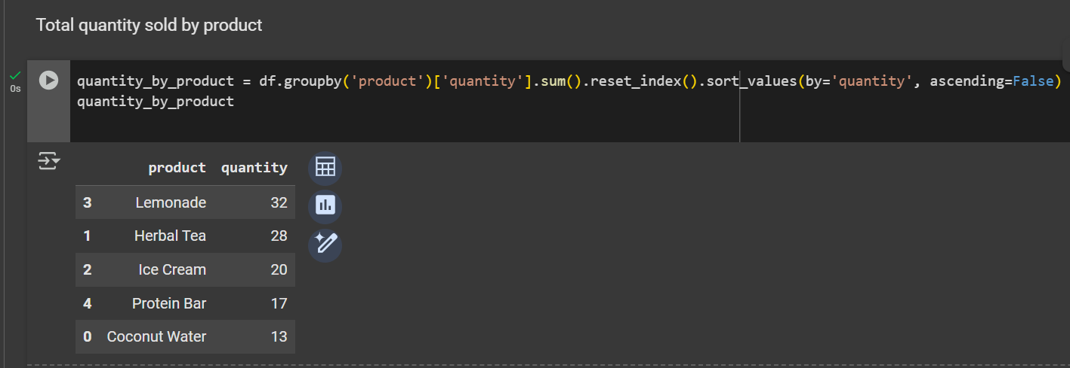

**2️⃣ Connected Python to SQLite**

Used sqlite3.connect() to establish a connection:

python

CopyEdit

conn = sqlite3.connect("sales_data.db")

**3️⃣ Ran SQL Query to Get Summary**

Used SQL to group data by product and calculate total quantity and revenue:

sql

CopyEdit

SELECT

product,

SUM(quantity) AS total_qty,

SUM(quantity * price) AS revenue

FROM sales

GROUP BY product

**4️⃣ Loaded Result into Pandas**

Used pd.read_sql_query() to fetch query results directly into a DataFrame:

python

CopyEdit

df = pd.read_sql_query(query, conn)

print(df)

**5️⃣ Plotted a Bar Chart**

Used matplotlib to create a bar chart of revenue by product:

python

CopyEdit

df.plot(kind='bar', x='product', y='revenue')

plt.title("Revenue by Product")

plt.xlabel("Product")

plt.ylabel("Revenue")

plt.tight_layout()

plt.show()

**✅ Visualization**

**📊 1. Bar Plot – Revenue by Product**

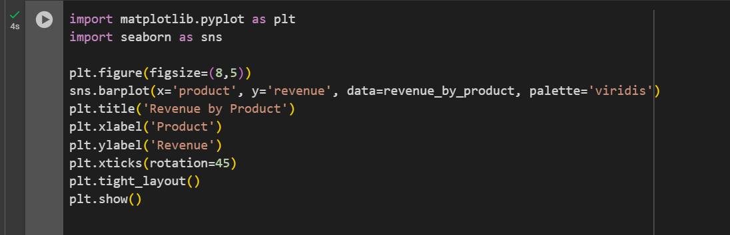

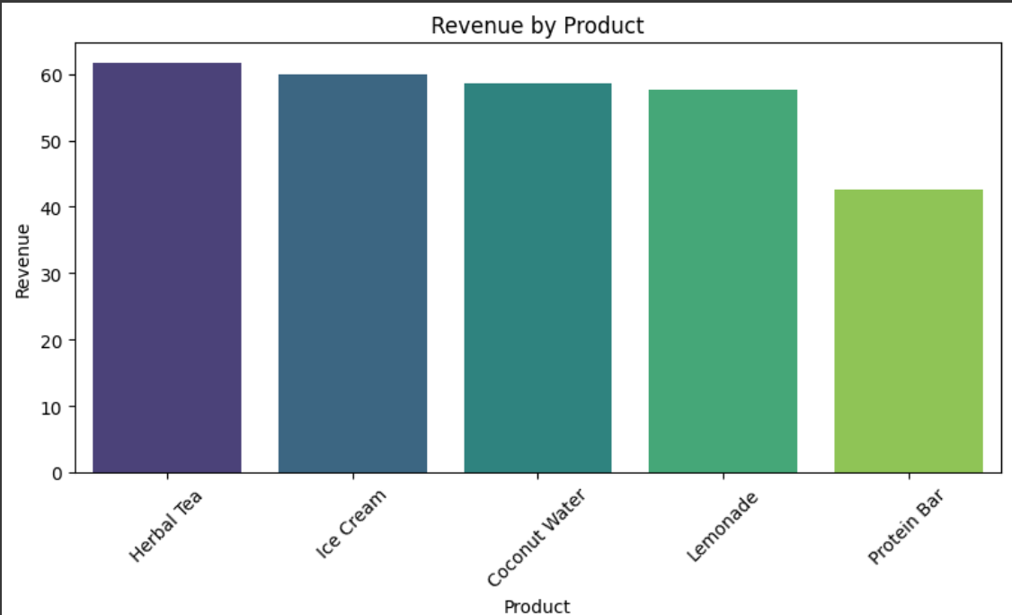

**🧁 2. Pie Chart – Product-wise Share in Total Quantity Sold**

